Electricity Billing System - Backend Documentation

1. Setup

Prerequisites
- Java 17+
- Maven 3.6+

Installation & Running
cd damien
mvn clean install
mvn spring-boot:run

Access Points
- API Base: http://localhost:8080
- H2 Console: http://localhost:8080/h2-console
- Swagger UI: http://localhost:8080/swagger-ui.html

Configuration (application.yml)
server:
port: 8080

spring:
datasource:
url: jdbc:h2:mem:electricity_db
username: sa
password: password

jwt:
secret: <base64-encoded-key>
expiration: 86400000 # 24 hours

2. Structure

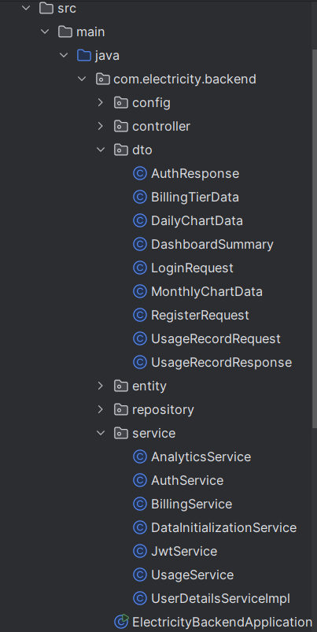

Architecture Pattern
Controller Layer (REST endpoints)
↓
Service Layer (Business logic)
↓
Repository Layer (Data access)
↓
Database (H2 in-memory)

Security Filter (JWT) → intercepts all requests

3. Logic

Database Schema
Users Table:
- id (Primary Key)
- account_number (Unique, used for login)
- username (Display name)
- password (BCrypt encrypted)
- role (USER or ADMIN)
- Timestamps: created_at, updated_at
UsageRecords Table:
- id (Primary Key)
- user_id (Foreign Key to Users)
- date (Date of reading)
- units_consumed (kWh)
- bill_amount (Calculated)
- billing_tier (Tier category)
- rate (Rate applied)
- created_at
Relationship: One User → Many UsageRecords

Authentication & Security Flow
- Registration:
  - User submits accountNumber, username, password
  - Password encrypted with BCrypt
  - User saved to database with USER role
  - JWT token generated and returned
- Login:
  - User submits accountNumber, password
  - Spring Security validates credentials
  - JWT token generated with 24-hour expiration
  - Token returned to client
- Protected Requests:
  - Client sends: Authorization: Bearer <token>
  - JwtAuthenticationFilter intercepts request
  - Validates token signature and expiration
  - Extracts accountNumber from token
  - Loads user from database
  - Sets authentication in SecurityContext
  - Request proceeds to controller
JWT Token Structure:
Payload: {
"sub": "ACC123456", // Account number
"iat": 1699878000, // Issued at
"exp": 1699964400 // Expiration
}
Signed with: HMAC SHA256

Billing Calculation Logic
Location: BillingService.java
Calculation Method:
public BillingResult calculateBill(double unitsConsumed) {
// Determines tier based on units
// Returns: billAmount, billingTier, rate
// Formula: billAmount = unitsConsumed × rate
}
Example:
45 kWh → Tier "31-60 kWh" → Rate LKR30/kWh → Bill = 45 × 30 = 1350

Core Business Logic
UsageService:
- addUsageRecord() - Creates usage record with billing calculation
- getDashboard() - Aggregates total units, bill, current tier
- getMonthlyData() - Sums usage for specific month
- getDailyUsage() - Retrieves recent daily records
AnalyticsService:
- getDailyChart() - Last N days usage for line chart
- getMonthlyChart() - Last N months aggregated data
- getBillingTiersChart() - Distribution across tiers (percentage)
AuthService:
- register() - Creates new user, encrypts password
- authenticateAndGenerateToken() - Validates and creates JWT
JwtService:
- generateToken() - Creates signed JWT with 24h expiration
- extractAccountNumber() - Parses token payload
- isTokenValid() - Validates signature and expiration

Key API Endpoints
Public (No Auth):
- POST /api/auth/register - Create account
- POST /api/auth/login - Login and get JWT
Protected (Requires JWT):
- POST /api/usage - Add usage record
- GET /api/usage/dashboard - Get dashboard summary
- GET /api/usage/monthly/{year}/{month} - Monthly data
- GET /api/usage/daily/{days} - Recent daily usage
- GET /api/analytics/charts/daily - Daily chart data
- GET /api/analytics/charts/monthly - Monthly chart data
- GET /api/analytics/charts/billing-tiers - Tier distribution
- GET /api/profile - User profile
Admin Only:
- POST /api/admin/usage - Add usage for any user
- GET /api/admin/users - List all users

4. Key Technologies
- Framework: Spring Boot 3.5.7
- Language: Java 17
- Database: H2 (in-memory)
- ORM: Spring Data JPA / Hibernate
- Security: Spring Security + JWT (jjwt library)
- Password Encryption: BCrypt
- API Docs: Swagger/OpenAPI
- Build: Maven

5. Security Configuration
SecurityConfig.java:
- Public access: /api/auth/**
- Admin access: /api/admin/** (ROLE_ADMIN)
- All other /api/** requires authentication
- Stateless sessions (no server-side session storage)
- CSRF disabled (JWT-based auth)
Password Encoding:
- BCrypt with 10 rounds
- Automatic on registration
- Validated by Spring Security on login

6. Running & Testing
Development:
mvn spring-boot:run
Build JAR:
mvn clean package
java -jar target/damien-1.0.0.jar
Test with Swagger:
- Go to http://localhost:8080/swagger-ui.html
- Register/login to get JWT token
- Click "Authorize" button, enter: Bearer <token>
- Test all endpoints interactively
H2 Database Console:
- Go to http://localhost:8080/h2-console
- JDBC URL: jdbc:h2:mem:electricity_db
- Username: sa, Password: password
- View tables and query data directly

